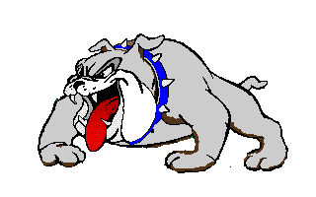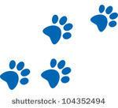

**Morton LiL’ Bulldogs**

**Classroom Attendance Wall of Fame**

September

October

November

December

January

February

March

April

May