Second Step Bullying Prevention Unit (SS-BPU)
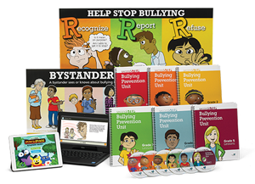

Description: The Second Step Bullying Prevention Unit (SS-BPU) is a whole-school bullying prevention program designed for grades K-5. A 30-minute interactive lesson plan is implemented each week over five lessons covering topics such as recognizing and reporting bullying, as well as bystander intervention. Descriptions of the lesson plans for grades K-3 and 4-5 can be found here. In addition, all school staff are provided with varying levels of training to implement the SS-BPU. Three training modules are completed by school staff to ensure a comprehensive and consistent understanding of bullying behaviors and intervention. All trainings are available to staff through the SS-BPU website. Module 1 of the staff training addresses implementation concerns for school principals and program coordinators, such as communicating bullying policies and procedures to staff and families. Module 2 addresses all school staff and assists in recognizing, responding to, and reporting bullying. Module 3 provides detailed training for those implementing the program (e.g., classroom teachers, counselors) to ensure understanding of the curriculum and lessons, as well as strategies for engaging families in the prevention program. In addition to activities and training directed students and school staff, the SS-BPU also includes a family component. Families are provided Home Link activities to build upon the topics discussed during that week’s school-based lessons. By including activities that address bullying knowledge and beliefs for students, families, and school staff members, the SS-BPU helps create a consistent skill base for addressing bullying across the most impactful settings for the child (i.e., school, home).

